**Dashboard Designing – Assignment**

Q1. Create the below groups using the Sub-Category field including Other. Then using a Pie Chart, determine the percent of Total Sales for Group 1 in the East Region. Also, use the color Palette Tableau 10 and assign the below colors to any of the groups.

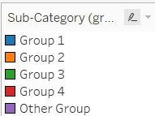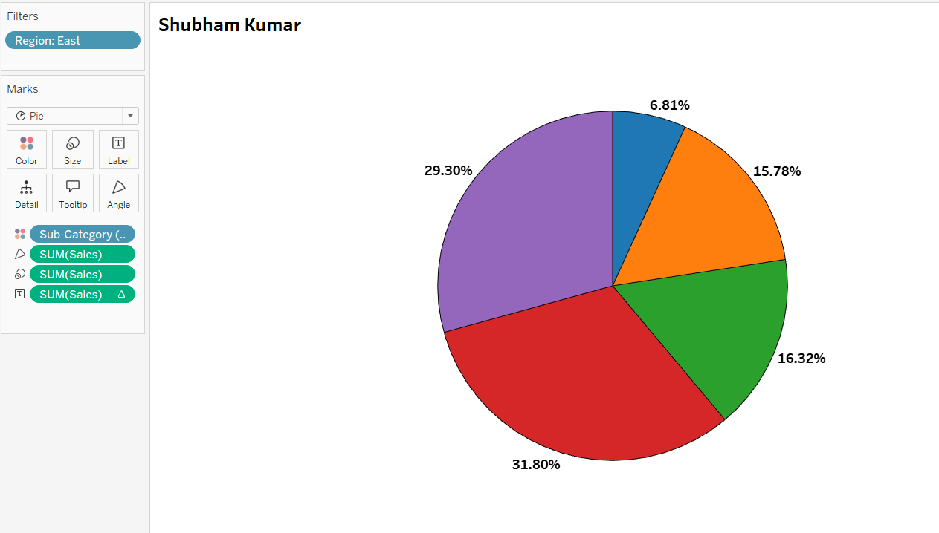

Q2 Create a Set for Bottom N customers by Sales. What is the percent of Total Sales formed by the Bottom 15, and the percentage of Total Sales formed by Bottom 45 customers? [Use Parameters]  
✔️ Bottom 15 - $811  
❌Bottom 45 – 0.32%

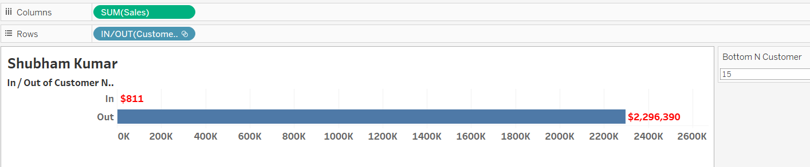

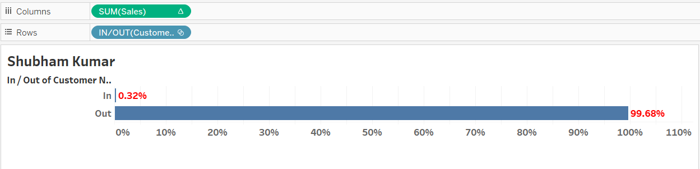

Q3 Create a Crosstab showing the Regions along with Sales Number for the State with Maximum Sales in that region in 2021. Table should have only 2 columns, Region and the Sales Value. [Hint: Use LOD]

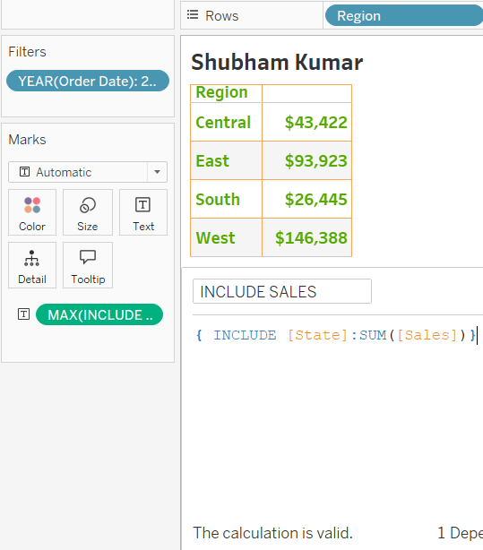

Q4 Using the Sample-Superstore dataset, determine what is the highest number of unique City-State combination?  
❌605  
✔️ 604  
❌584  
❌532

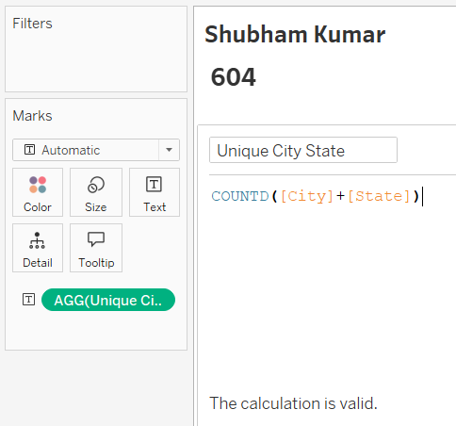

**Dashboard Designing**

Create a Dashboard and drag 2 sheets to the dashboard.

Sheet 1: Drag the resultant Pie chart from Q1 to the dashboard.

Sheet 2: Drag the sheet showing total sales in Thousands by Ship Mode, except the Standard Class for the year 2021 into the Dashboard. Attach screenshot for at least one.

